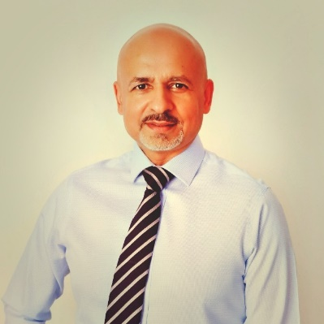

Dr Hanif has over 30 years of international project delivery experience gained in the United Kingdom, State of Qatar, United Arab Emirates and the Kingdom of Saudi Arabia.
His involvement has been with the delivery of projects for clients in the Government, Nuclear, IT, Banking, Retail, Infrastructure, Military and Hospitality sectors.
This includes strategy, project definition, appointment of consultants/contractors, contract administration, financial management, risk management, project controls, forensic planning and project reporting.
Dr Hanif is Associate Professor at South Ural State University, Russian Federation, where he is responsible for teaching project management to construction graduate and post-graduate students.

